HCL Sri Lanka – Java Badge 03

Team 03

Online Pizza Ordering System

Team Members:-

Leader : - Shavini Fernando

Members:- Hashan Gayantha

Mayuran Mathivathanan

Buddhi Kalpana

**Table of Content**

1. Introduction
2. Design and detailed Technical Updates
   1. Process Model
      1. Use Case Model
      2. Use Case Scenarios
      3. ER Diagram
      4. Class Diagram
   2. HTML/CSS Implement of web pages
3. **Introduction**

The food ordering system is for easy ordering purpose of food ordering process with the shop and the customers. Here the customers will be able to register and login to the system to set orders by selecting available food items at the moment.

**02. Design and detailed Technical Updates**

* 1. Process Model
     1. Use Case Model

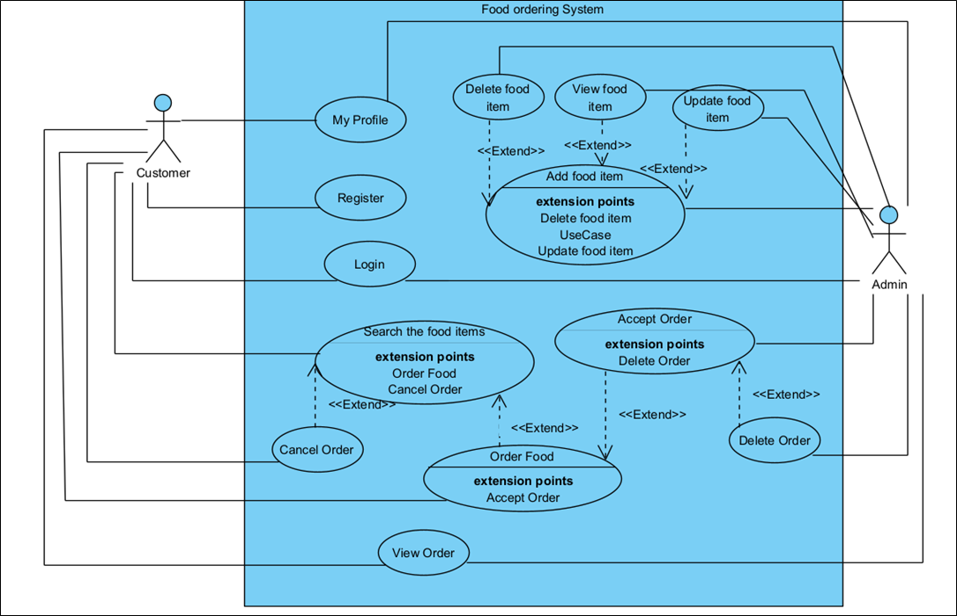

* + 1. Use Case Scenarios

|  |  |
| --- | --- |
| Brief Description | Customer Login |
| Basic Flow | This use case describes how customer is allowed to login to the system.   1. Customer has to login to the system to order the food through system. 2. To login to the system customer has to provide username and password which were given when registering to the system.   After successful login, customer will be able to see the relevant home page. |
| Alternate Flow | If the customer cannot remember the password, these steps can be followed.   1. Customer can select Forgot Password option. 2. Customer can give their email to send one time password through email. 3. Customer can provide that password and login to the system.   The customer can login via email account. |
| Validation | 1. Username and password both should be correct to access to the system.  2. Username or password fields should not be empty. |
| Pre - Conditions | User must be a registered person to the system via register option. |
| Post - Conditions | The system should display the relevant home page. |

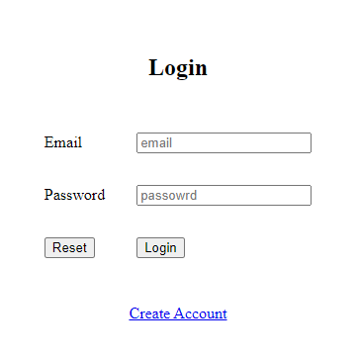

|  |  |
| --- | --- |
| Brief Description | Customer Registration |
| Basic Flow | This Use Case allows new Customers to Register in to the system.   1. Customer need to register in to the system in order to order the food. 2. The following fields are required during registration.  * First Name * Last Name * Email * Phone Number * Password * Confirm Password  1. After the successful data input customer will receive a success message. |
| Alternate Flow | 1. The System will validate the provided data in each field. For any invalid data the system will provide an error message. |
| Validation | 1. First name and Last name fields are required minimum 3 and maximum 15 Characters. Cannot Include alphanumeric. 2. Valid email should be provide. 3. Phone number field cannot enter any letters or characters. 4. Password should be maximum 8 characters |
| Pre - Conditions | Customer should have network connection and browser. |
| Post - Conditions | Customer should get successful message. |

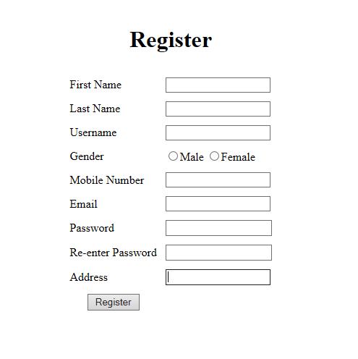

|  |  |
| --- | --- |
| Brief Description | Searching for Food and Order |
| **Basic Flow** | 1. Customer must have an account.  2. Then search for food. |
| **Alternate Flow** | 1.The system is validating the input information if the data is available or not.  2. If it’s not alert message notified. |
| **Pre-condition** | 1. Customer must have an account.  2. Network access and preferred App or application. |
| **Post Conditions** | 1.Search food will be displayed successfully.  2.Then ordered successfully. |

|  |  |
| --- | --- |
| Brief Description | Add to cart |
| **Basic Flow** | 1.Customer must have an account after that customer has to login through account and add to cart feature is available.  2.Customer must select food item or food package for add to cart. |
| **Alternate Flow** | 1.Customer can access through guest account for add to cart option. |
| **Pre-condition** | 1.Customer must be registered to an account for add to cart option. |
| **Post Conditions** | 1.The food should be added to add to cart option. |

|  |  |
| --- | --- |
| Brief Description | Cancel Order |
| **Basic Flow** | 1.Customer must have an account for cancel food order.  2.Customer must select food or food package to cancel order. |
| **Alternate Flow** | 1. Customer can access through guest account for cancel food order option. |
| **Pre-condition** | 1.Customer must be registered to the account for cancel order and more features. |
| **Post Conditions** | 1.The food order should be canceled. |

* + 1. ER Diagram

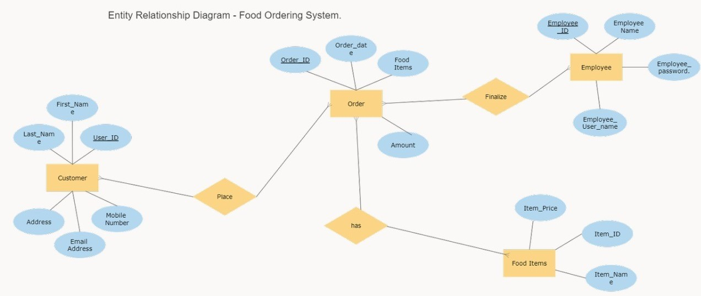

* 1. HTML/CSS Implement of web pages

01.Login Page

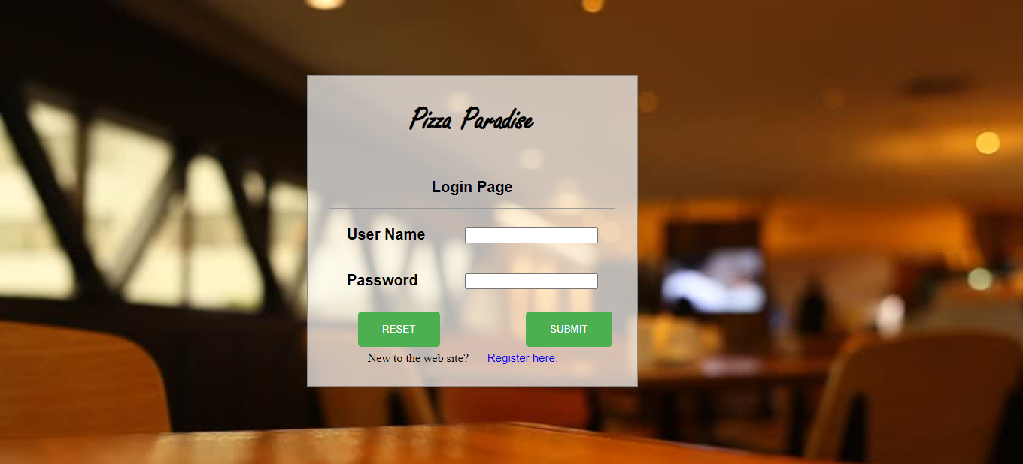

02.Register Page

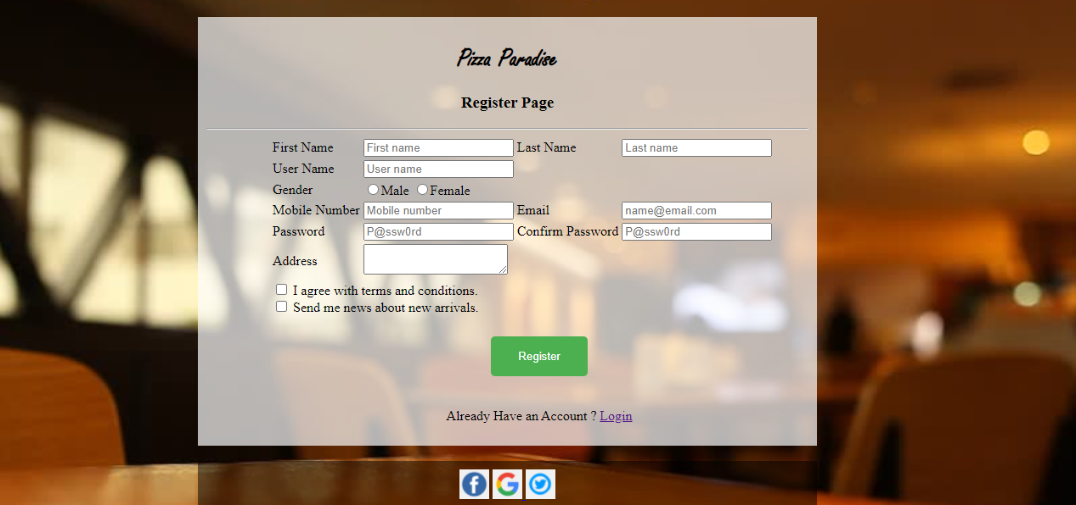

03.Home Page

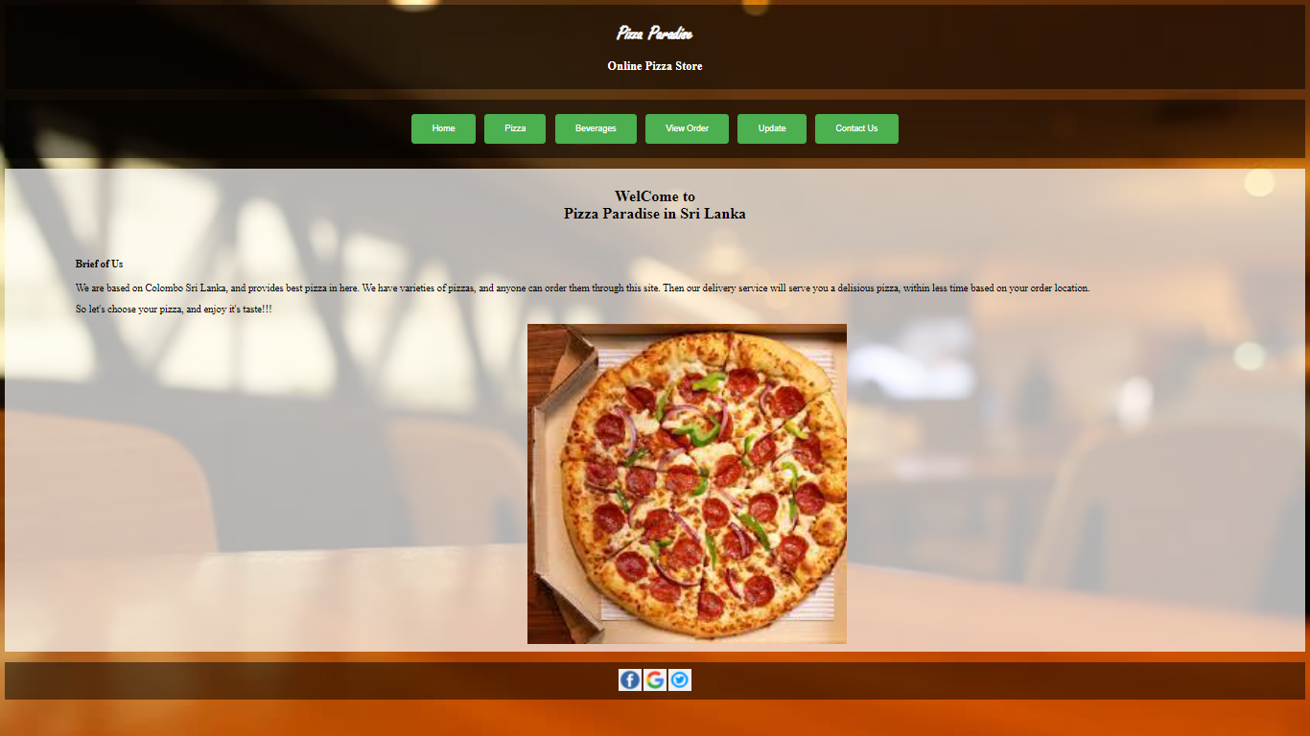

04. View Order

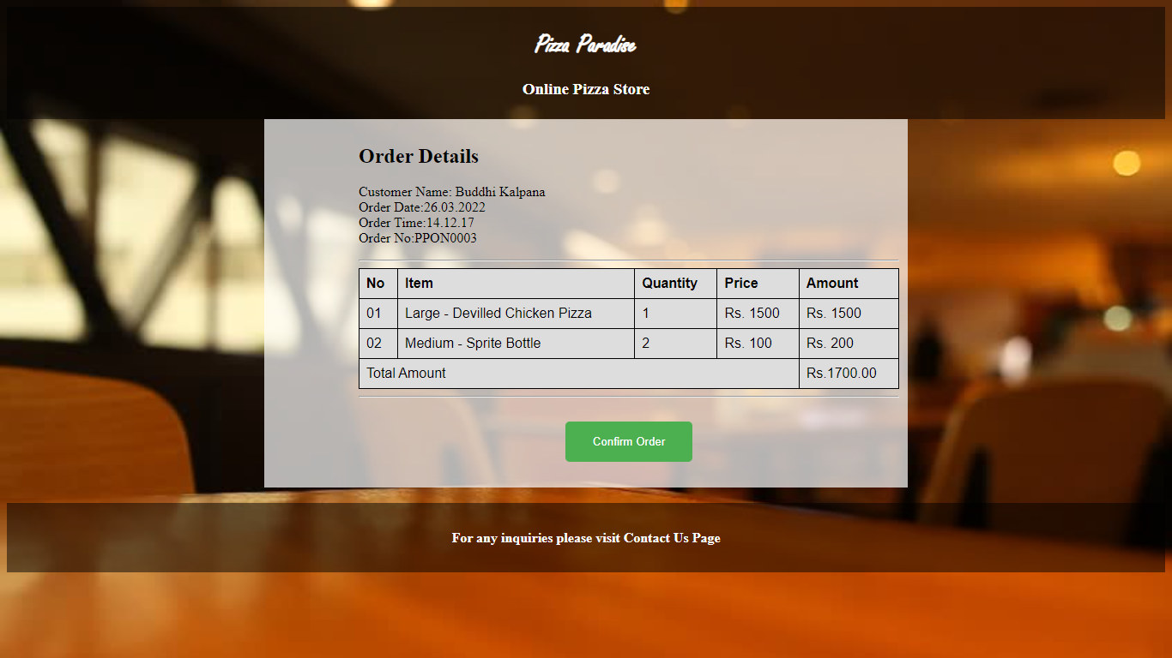

05. View Order Details

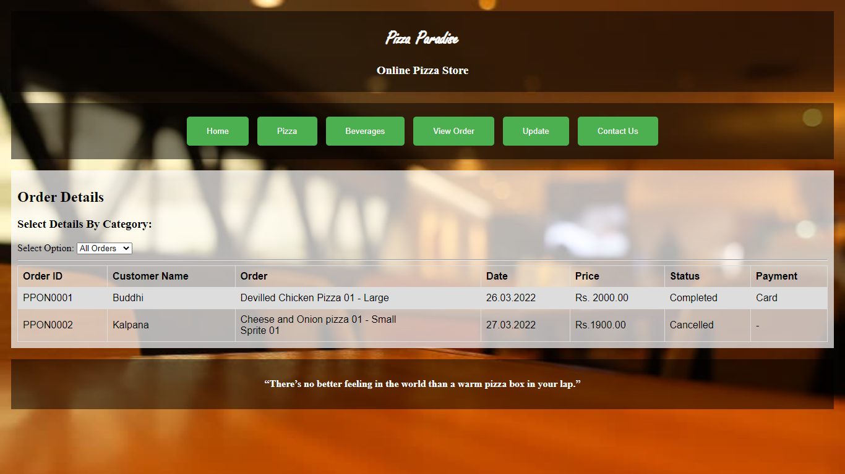

06. Add Item Page

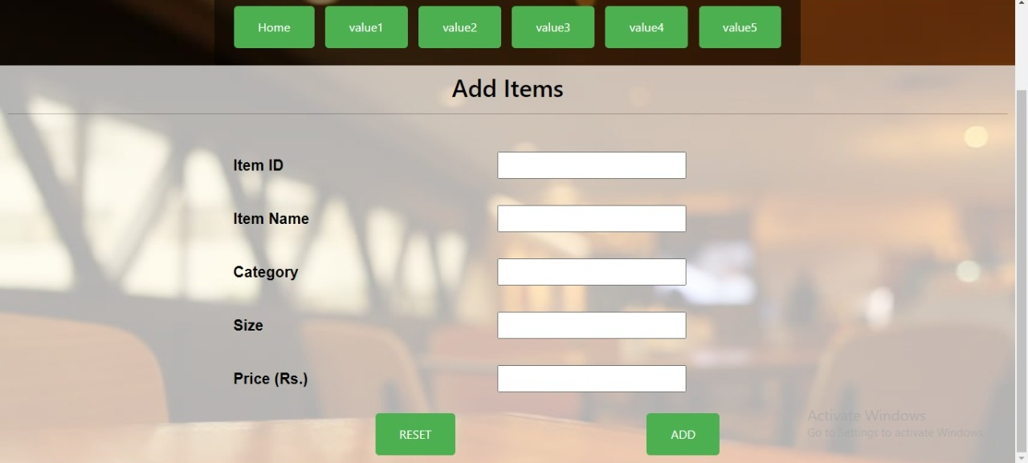

07. Available Food Item Page

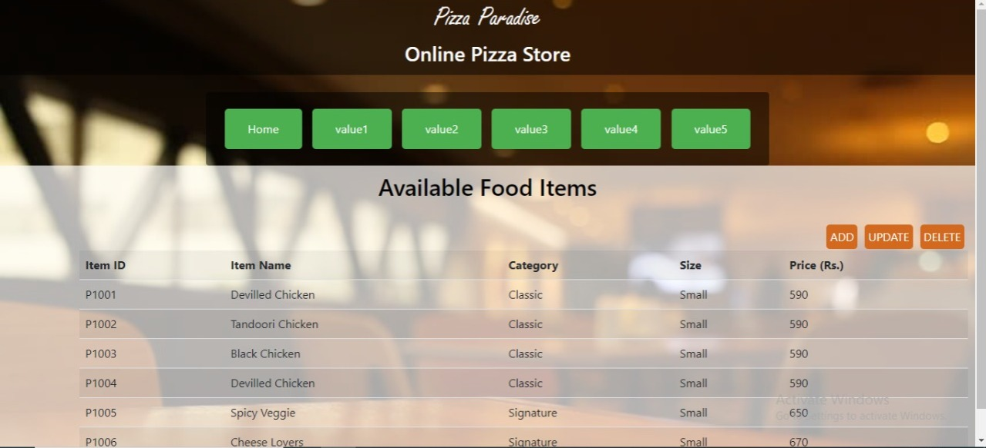

08.Contact Us Page

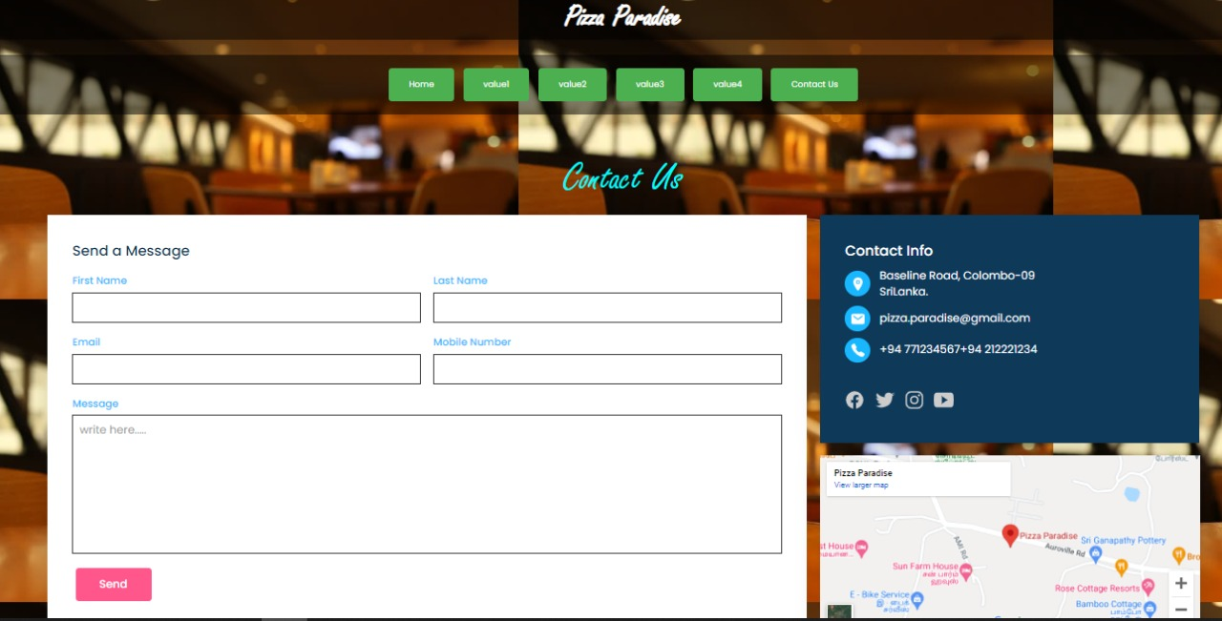

09. Beverages Page

